Work report 16 july 2021

Today I have completed the training till 1500 epochs. The loss fluctuates around 26 to 32.The results are as follows:

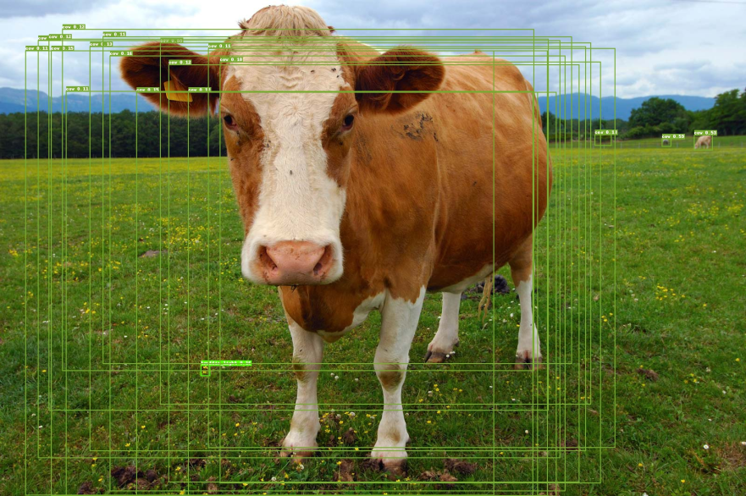

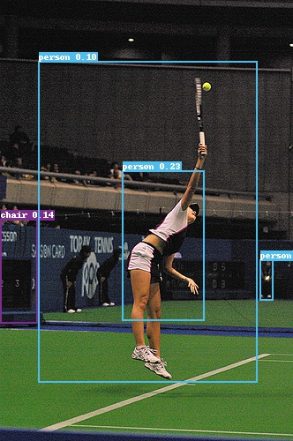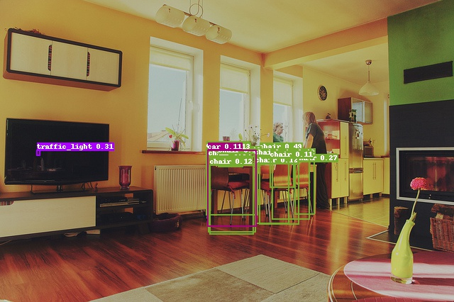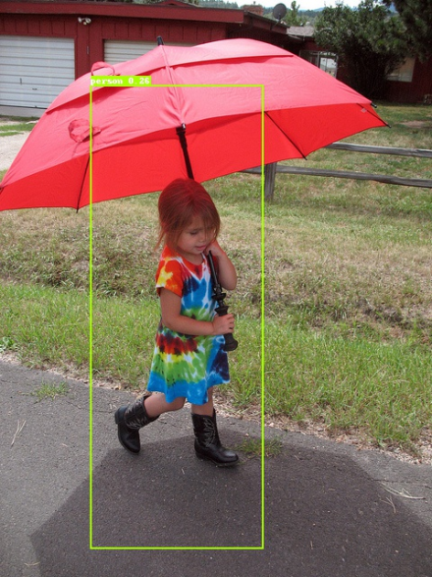

So as discussed , I have continue the training of the model till 3000 epochs .

I have reached till 1659 th epoch. The loss is still fluctuating around 27 to 33.

